In this assignment we were tasked with taking raw data from a cancer pharmaceutical study and break it out into useful informative chunks. In doing so I discovered a few interesting things.

1. It appears that out of all the drugs tested, Capomulin and Ramicane provide the best results. They showed the smallest tumor size at the end of the study comparatively to the other regimens.

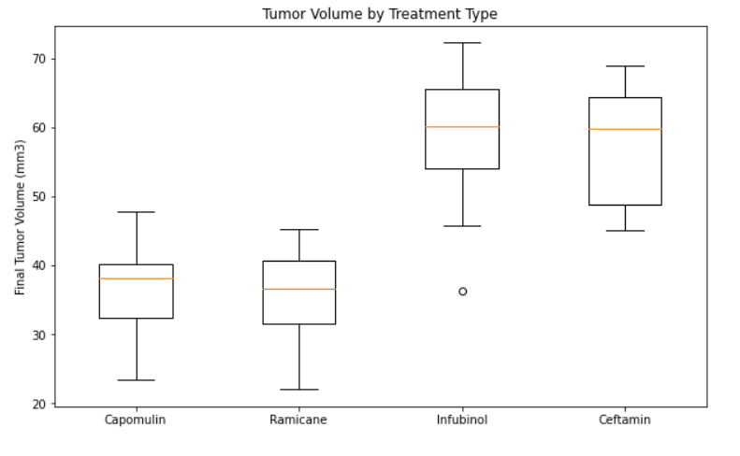

1. In the end, there is a direct positive correlation between average tumor volume and the weight of the mouse. This could be due to the larger the size of the tumor, the heavier the mouse.

